1. **Write a program to print Hello Students on the screen.**

#include<stdio.h>

int main()

{

printf("Hello");

return 0;

}

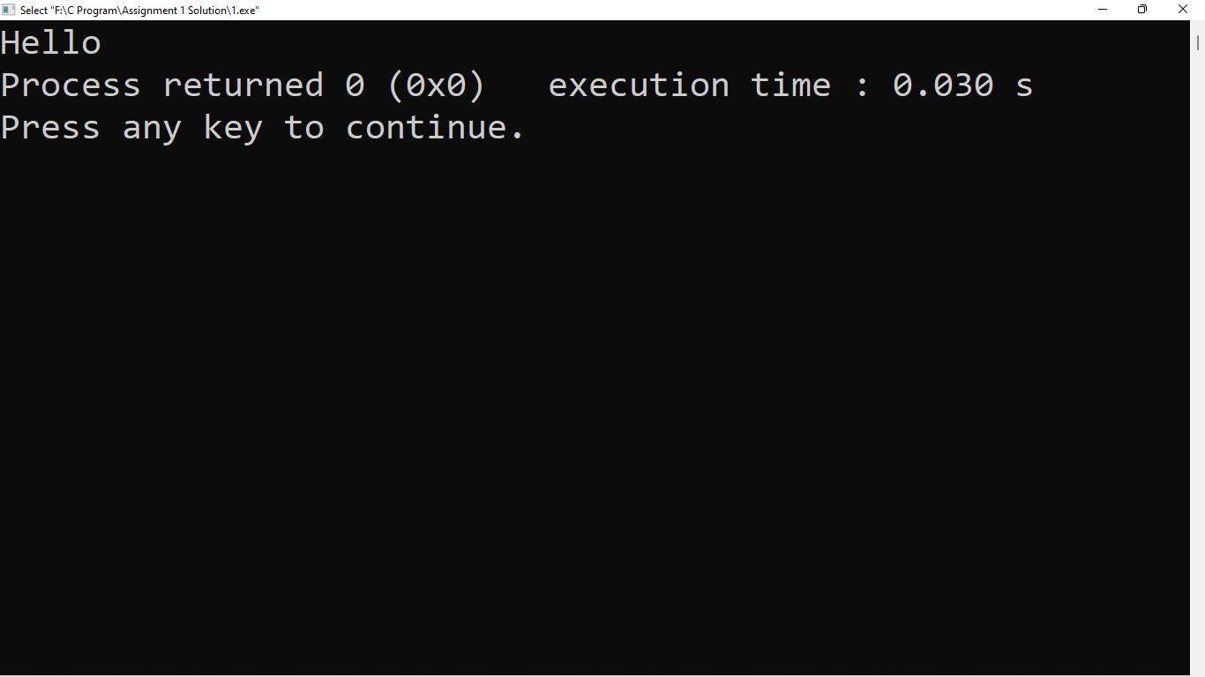

1. **Write a program to print Hello in the first line and Students in the second line.**

#include<stdio.h>

int main()

{

printf("Hello\nStudent");

return 0;

}

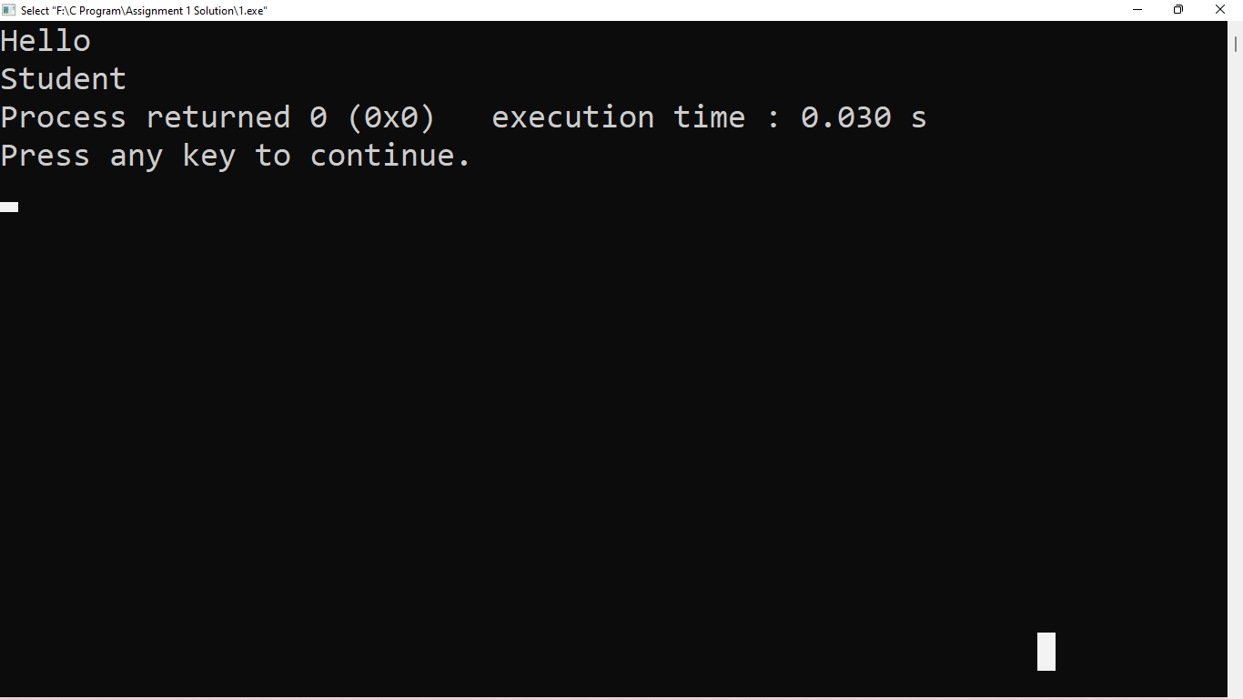

1. **Write a program to print “MySirG” on the screen. (Remember to print in double quotes)**

#include<stdio.h>

int main()

{

printf("\"MySirG\"");

return 0;

}

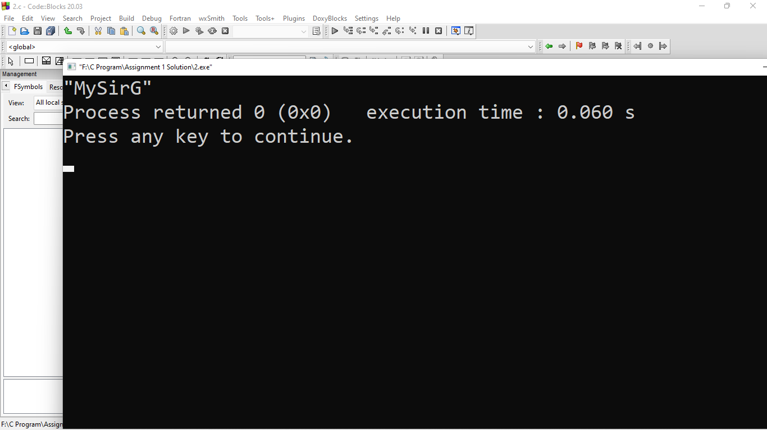

1. **WAP to find the area of the circle. Take radius of circle from user as input and print the result in below given format.**

#include<stdio.h>

int main()

{

int r;

float a;

printf("Enter radius of circle:-\n");

scanf("%d",&r);

a=3.14*r*r;

printf("Area is %f",a);

return 0;

}

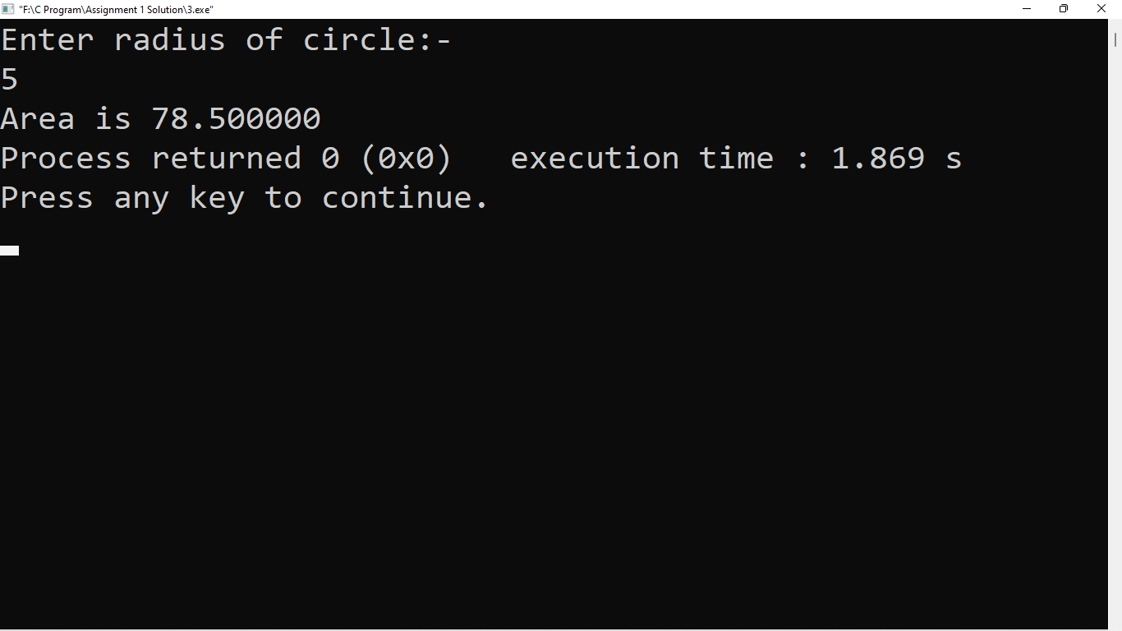

1. **WAP to calculate the length of String using printf function.**

#include<stdio.h>

int main()

{

int r;

r=printf("Viraj");

printf("%d",r);

return 0;

}

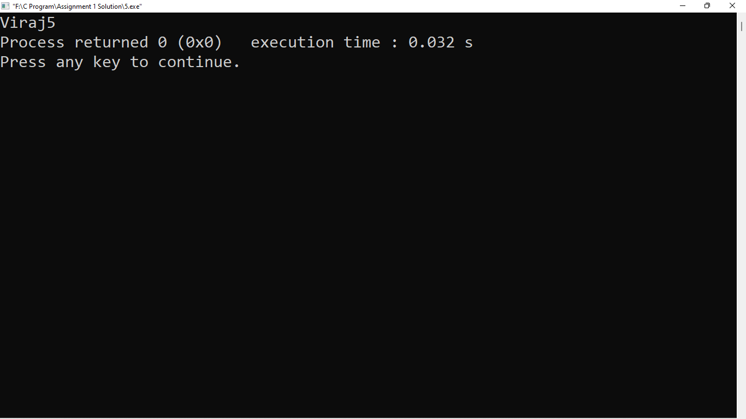

1. **WAP to print the name of the user in double quotes.**

#include<stdio.h>

int main()

{

printf("\"Viraj\"");

return 0;

}

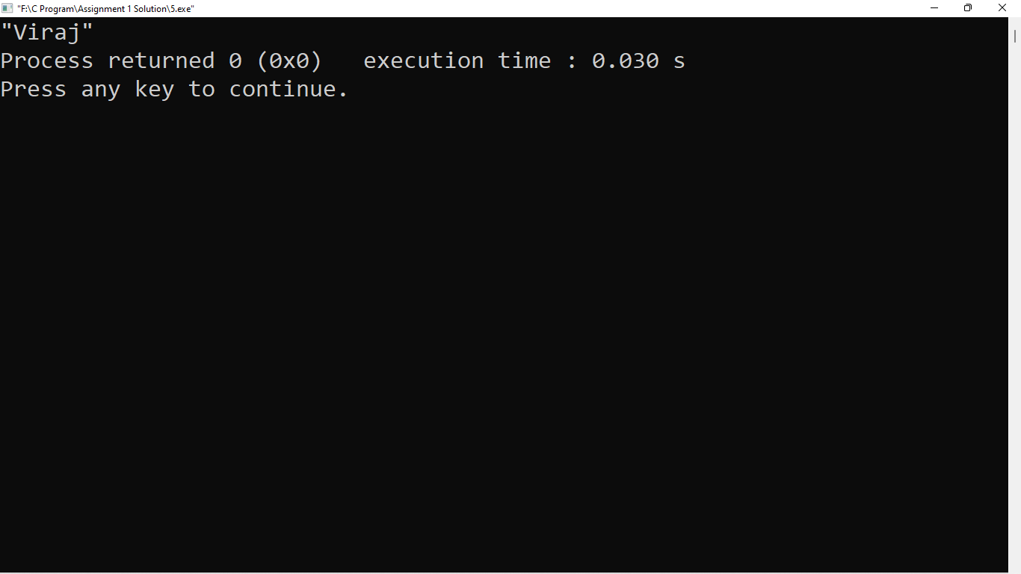

1. **WAP to print “%d” on the screen.**

#include<stdio.h>

int main()

{

printf("%%d");

return 0;

}

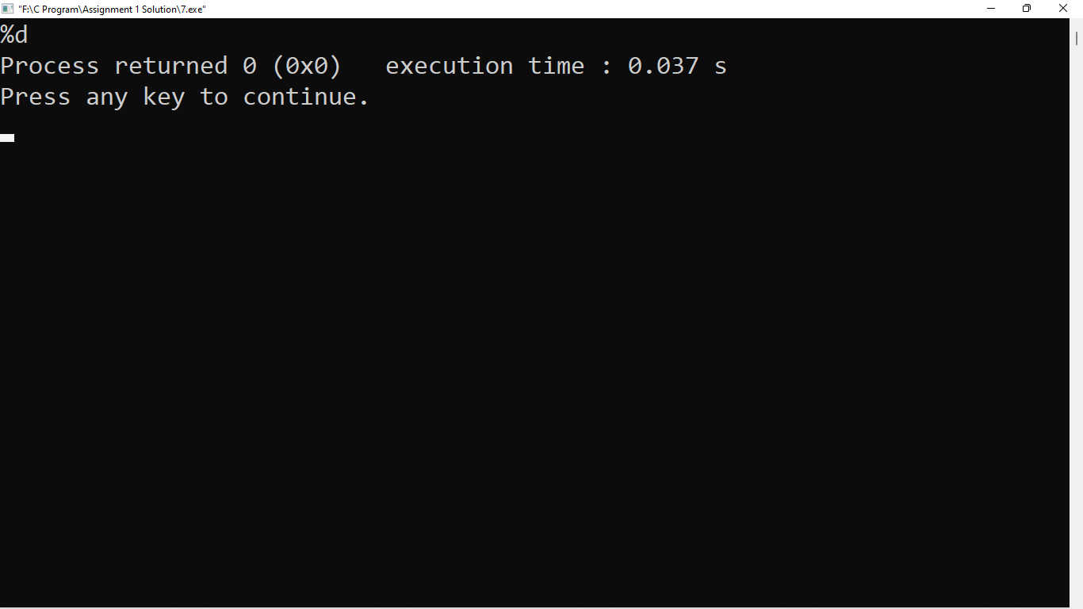

1. **WAP to print “\n” on the screen.**

#include<stdio.h>

int main()

{

printf("\\n");

}

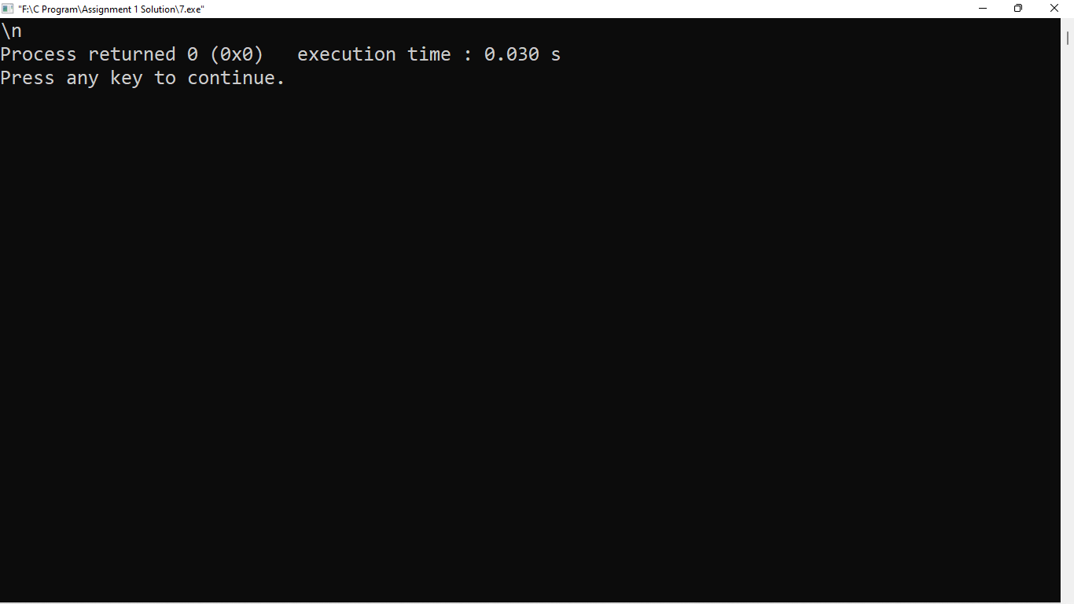

1. **WAP to print “\\” on the screen.**

#include<stdio.h>

int main()

{

printf("\\\\");

}

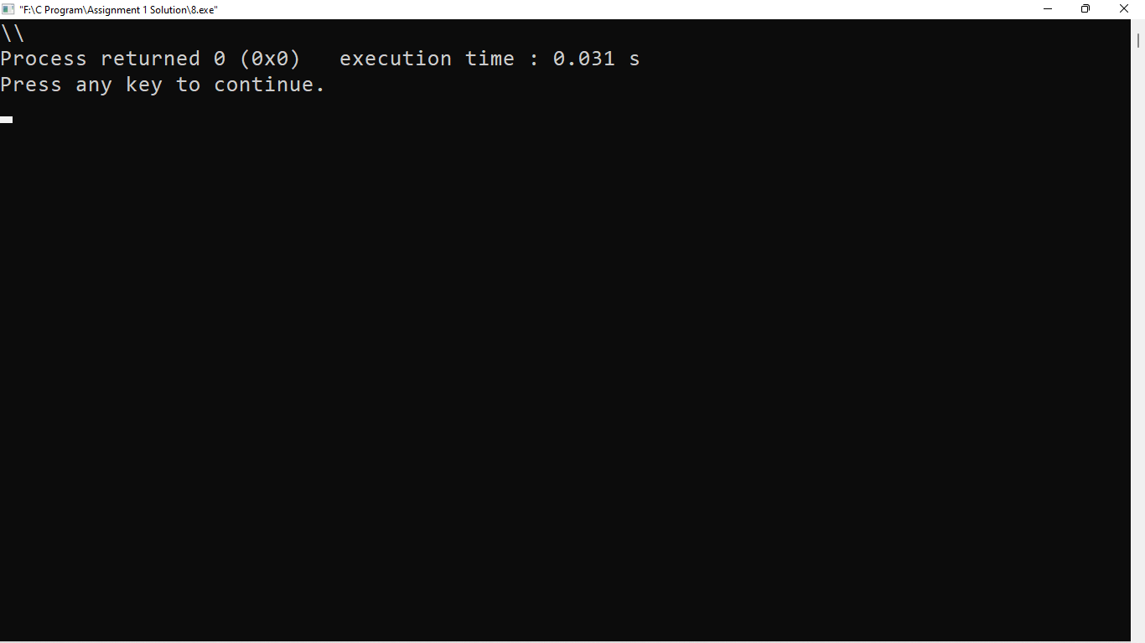

1. **WAP to take date as an input in below given format and convert the date format and display the result as given below.**

**User Input date format – “DD/MM/YYYY” (27/11/2022)**

**Output format – “Day – DD , Month – MM , Year – YYYY” (Day – 27 ,Month – 07 , Year – 2022)**

#include<stdio.h>

int main()

{

int DD,MM,YYYY;

printf("Enter Date:-\n");

scanf("%d/%d/%d",&DD,&MM,&YYYY);

printf("Day-%d,Month-%d,Year-%d",DD,MM,YYYY);

return 0;

}

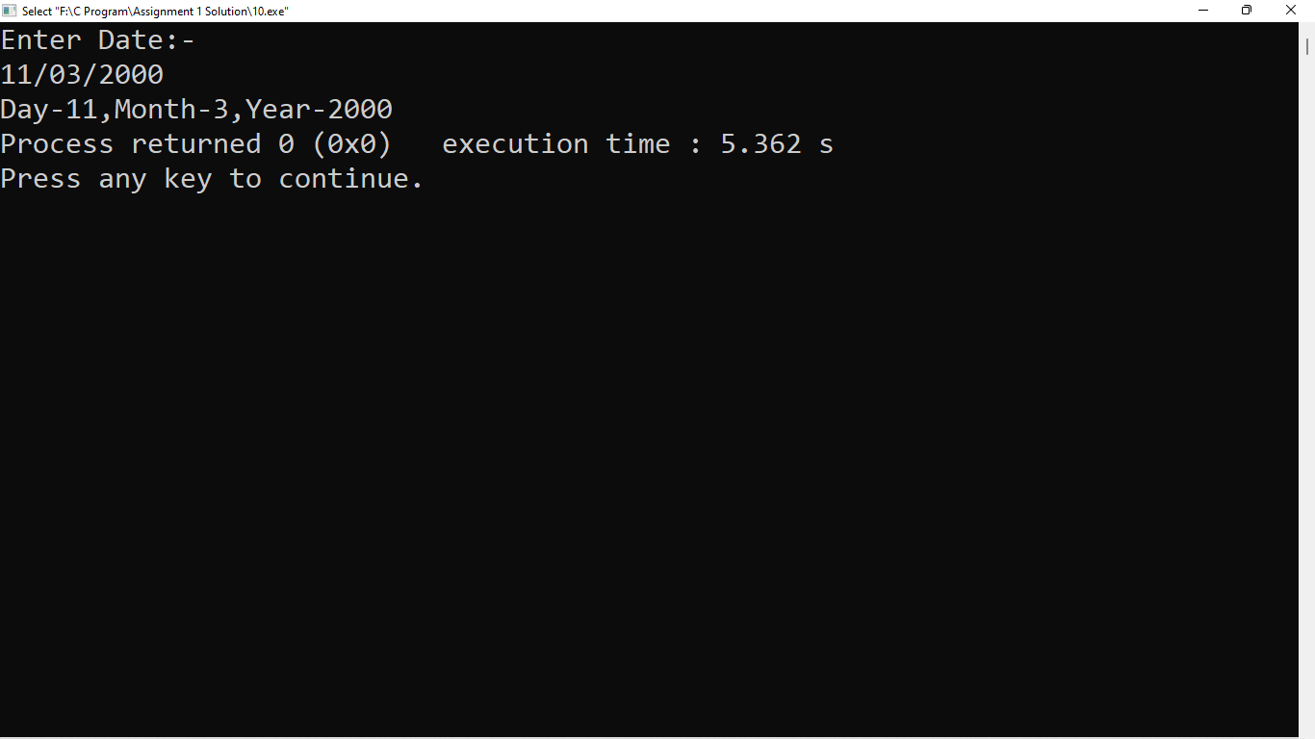

1. **WAP to take time as an input in below given format and convert the time format and display the result as given below.**

**User Input date format – “HH:MM”**

**Output format – “HH hour and MM Minute”**

**Example –**

**“11:25” converted to “11 Hour and 25 Minute”**

#include<stdio.h>

int main()

{

int HH,MM;

printf("Enter Time:-\n");

scanf("%d:%d",&HH,&MM);

printf("%d Hour and %d Minute",HH,MM);

return 0;

}

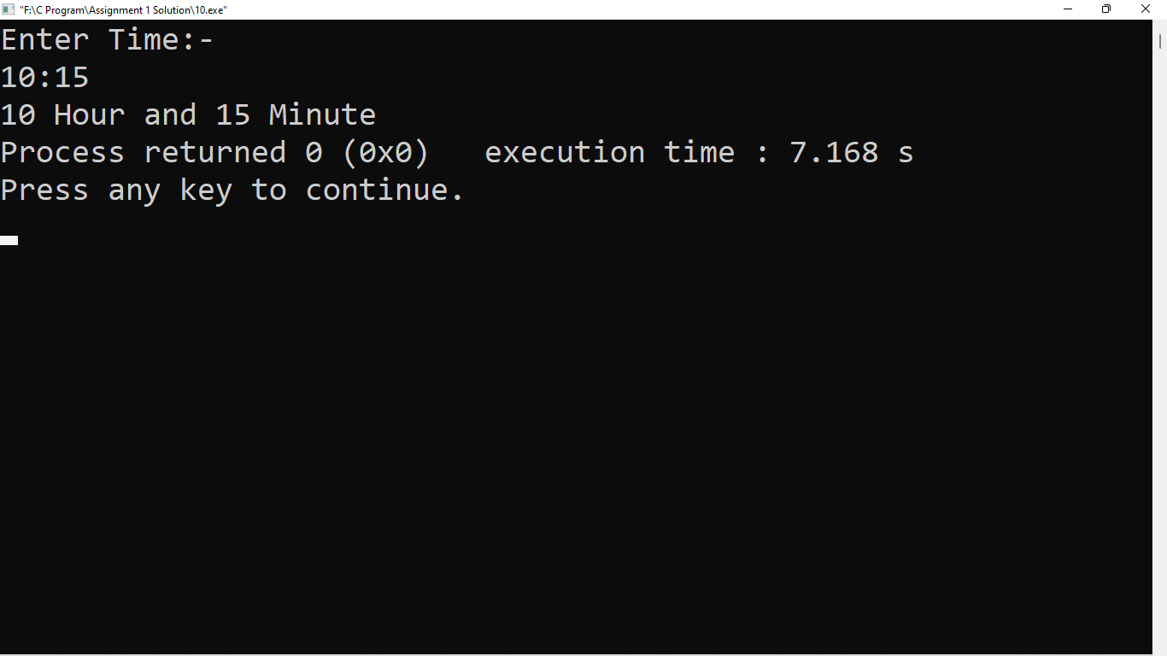

1. **Find output of below code:**

**int main()**

**{**

**int x = printf(“ineuron”);**

**printf(“%d”,x);**

**return 0;**

**}**